**BIOMAGNIFICATION**

The increase in the concentration of a fat soluble toxin as one moves up the food chain. For instance:

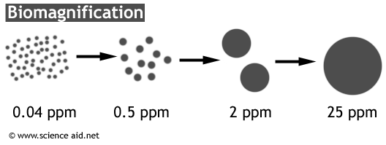

EXAMPLE: Zooplankton 🡪 Sandhopper 🡪 Claspper Rail 🡪 Marsh Hawk

Animals exposed to large amounts of fat soluble toxins, like hormones, store a lot of it in their system because it is not removed from the body like most wastes. As a result, animals that are higher up on the food chain will slowly accumulate a high concentration of this toxin (hormone) over time and pass it on to any predators.

The following hormones are steroids… steroids are a type of lipid… therefore these hormones mix with fat:

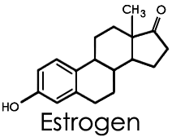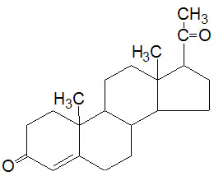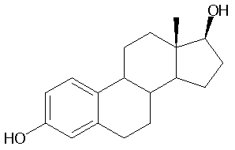

Progesterone Testosterone

**Vocabulary:**

Concentration:______________________________________________________________________________________

__________________________________________________________________________________________________

Soluble:____________________________________________________________________________________________

__________________________________________________________________________________________________

*\*Fat soluble:____________________________________________________________________________________*APPLYING BIOMAGNIFICATION

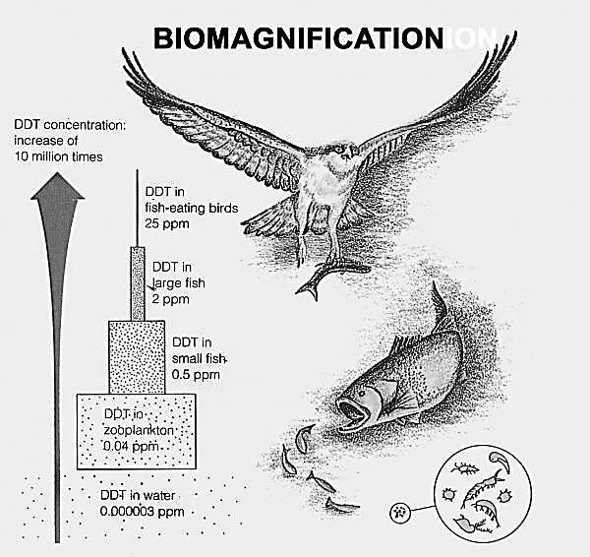

1. Using the food chain, what animal has:
   1. The highest concentration of DDT in its body?
   2. The lowest concentration of DDT in its body?
   3. The second highest concentration of DDT in its body?
   4. The second lowest concentration of DDT in its body?
2. How does the concentration of pollutants in the small fish compare to the concentration in the fish-eating bird?
3. Explain why the fish-eating bird has a greater concentration of DDT than the large fish in the diagram above.
4. If a concentration of 2 ppm or more can cause birth defects in organisms, and a concentration of 10 or more can cause cancer and potential death, which organisms in the food chain could have offspring with birth defects and which could even die from the levels of contamination?
5. Write two conclusions that can be drawn from the graph.