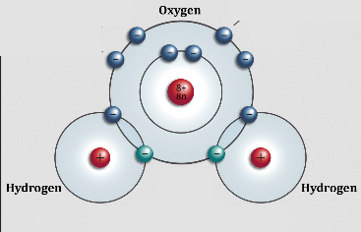
Atoms and molecules
Science Wednesday
- Atoms are made of tiny particles that are constantly in motion.
- These particles have electrical charges – a little zing! – and attract particles from other atoms & molecules.
- FOR EXAMPLE: Magnets are made of elements that have a strong positive charge on one side and a strong negative charge on another.
- DID YOU KNOW: Water molecules are a tiny bit magnetic too. Notice how water molecules stick to each other and to anything you dissolve in water.
Challenge 1: Try out a magnet:
- Use any of the magnets on the table to connect to other magnets or to pick up pieces of metal

Challenge 2: Make a cup of tea:
- Dissolve tea in a cup of warm water
- THINK LIKE A SCIENTIST: Imagine that each water molecule and each water droplet is like a magnet, attracting the particles of tea.

Challenge 3: Over-fill a container with water

- Use a dropper to fill up a container with water.
- Keep adding more water to see if you can fill the container higher than the edges without spilling.
- THINK LIKE A SCIENTIST: Why does this work?

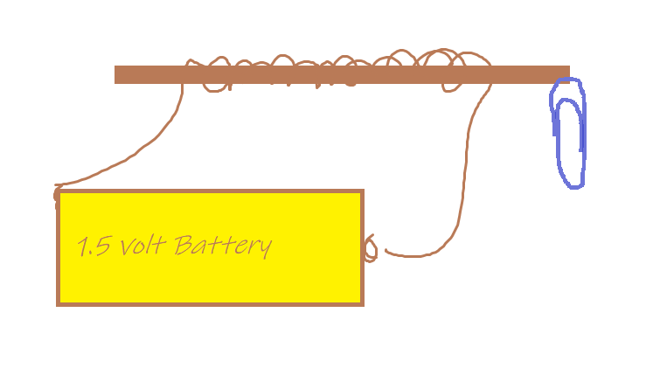
Challenge 4: Make an electromagnet:
- Wrap wire around a straight piece of metal (bolt or nail).
- BRIEFLY attach both ends of the wire to a battery
- Test to see if the electromagnet will pick up a paperclip
- Quickly disconnect the electromagnet before it gets too hot.
- Use cardboard to design a frame for the electromagnet.
- THINK LIKE AN INVENTOR: How could you use an electromagnet to make something useful?

Challenge 5: Un-make a cup of tea:

- Can you use some type of filter to turn the cup of tea back into clear water?
- THINK LIKE AN INVENTOR: How can you use filters to make something useful?

